HACKATHON PROJECT REPORT
Maze Solver Game
Comparing BFS, DFS and Backtracking
Visualize. Explore. Compare.
Item | Details
Team members | Vinesh (Roll No. 25MVCSMR0064); [TEAM MEMBER 2]; [TEAM MEMBER 3]; [TEAM MEMBER 4]
College | Malla Reddy Technical Campus
Department | Department of Computer Science and Engineering (AI & ML) [confirm exact name]
Hackathon | [INSERT HACKATHON NAME]
Subject area | Design and Analysis of Algorithms (DAA)
Academic year | [INSERT ACADEMIC YEAR]

Table of Contents
- 1. Cover Page
- 2. Abstract and Introduction
- 3. Problem Statement, Objectives and Scope
- 4. Features and Functional Requirements
- 5. Algorithms and Methodology
- 6. Technologies and Implementation
- 7. Results, Testing and Performance
- 8. Conclusion, Future Scope and References

How to read this report
This report is written for beginners. Every technical word is explained the first time it appears. Where a number from the running application is needed, you will see a yellow placeholder such as [INSERT ACTUAL BFS RESULT]. Replace these with the values shown by your own run of the application (see Section 7). Values that are not placeholders were produced by running the project code.

Glossary of simple terms
Term | Simple meaning
Algorithm | A step-by-step set of instructions to solve a problem.
Grid | A table of rows and columns. Our maze is a grid.
Cell | One square of the grid, written (row, column).
Queue | A line of people: the first one in is the first one out (FIFO).
Stack | A pile of plates: the last one placed is the first one taken (LIFO).
Recursion | A function that calls itself to solve a smaller version of the same problem.
Visited cell | A cell the algorithm has already looked at.
Path length | Number of steps (moves) from Start to Goal.
Dead end | A place from which you cannot go forward to any new cell.
Unweighted maze | Every move costs the same (1 step).
Big-O (O) | A way to describe how the work grows when the input grows.

2. Abstract and Introduction

2.1 Abstract
The Maze Solver Game is an interactive web application that helps students see how three classic search techniques work: Breadth-First Search (BFS), Depth-First Search (DFS) and Recursive Backtracking. The user can generate a random solvable maze (Easy, Medium or Hard) or type in their own maze, choose an algorithm and watch it search step by step. Each algorithm records its important decisions as events, and the interface replays those events with colours and a short plain-English message. The application measures path length, number of visited cells, execution time and the number of backtracking operations, and it compares all three algorithms on exactly the same maze. The project is written in Python with Streamlit and Matplotlib and runs locally with a single command.

2.2 What is this project?
Imagine you are standing at the entrance of a maze and want to reach the exit. There are many ways to search: you could check all nearby corridors first, or you could follow one corridor as far as possible, or you could try a choice and undo it if it fails. These three ideas are exactly BFS, DFS and Backtracking. Our project is a small game-like tool that lets you watch each idea in action on the same maze and compare the results with numbers.

2.3 Why are maze-solving algorithms useful?
A maze is a simple model of a very common problem: finding a route through a set of connected places. The same ideas are used in many real systems:
- Navigation and maps: finding a route between two places on a road network.
- Games: non-player characters finding their way around obstacles.
- Robotics: a robot vacuum or warehouse robot planning a route around walls and shelves.
- Networks: discovering which computers are connected and how many hops apart they are.
- Puzzles and planning: Sudoku, N-Queens and scheduling use backtracking to try choices and undo bad ones.
- Web crawling and file search: visiting pages or folders level by level (BFS) or deeply (DFS).

2.4 Why is visualization useful?
Reading pseudocode on paper shows what the algorithm is, but not what it does. Many students can recite "BFS uses a queue" without ever picturing how the search spreads out like a ripple. When the search is animated, the difference becomes obvious: BFS grows a ring, DFS dives into a corridor, and Backtracking walks forward and then visibly retreats. Seeing the decisions makes the algorithms easier to remember, easier to explain to others, and easier to debug.

2.5 What does the application do?
- Creates a random maze that is guaranteed to be solvable, or accepts a maze typed by the user.
- Lets the user pick BFS, DFS or Backtracking and press Solve.
- Replays the search step by step, with Play, Prev, Next, a step slider and an animation speed control.
- Shows a message for every step, such as "DEAD END at (5, 7): every option failed".
- Reports path length, visited cells, average time and backtracking count.
- Runs all three algorithms on the same maze and shows a comparison table, bar charts and final pictures.

2.6 Report organisation
Section 3 states the problem and scope. Section 4 lists the features and functional requirements. Section 5 explains the algorithms. Section 6 describes the technology and implementation. Section 7 presents tests and results. Section 8 concludes with future work and references.

3. Problem Statement, Objectives and Scope

3.1 Problem statement
Generate or accept a maze and let users compare BFS, DFS and Backtracking solutions by path length, number of visited cells and execution time. The system should make the algorithm's important decisions visible rather than only displaying the final answer. The application should allow users to generate or create a maze and solve the same maze using BFS, DFS and Backtracking, with the solving process visualized step by step.

3.2 Understanding the problem in simple words
- Input: a maze (a grid with walls, one Start and one Goal).
- Task: find a route from Start to Goal moving up, down, left or right through open cells.
- Output 1: the route (or a clear message that no route exists).
- Output 2: the story of the search (which cells were looked at, in what order, and which choices were undone).
- Output 3: numbers that let us compare the algorithms.

3.3 Objectives
# | Objective | How it is met
O1 | Implement BFS correctly | bfs.py uses a queue, parent links and path reconstruction.
O2 | Implement DFS correctly | dfs.py uses a stack and visited set.
O3 | Implement Backtracking correctly | backtracking.py uses recursion with choose / explore / undo.
O4 | Interactive maze | Random generator, difficulty levels and manual editor.
O5 | Step-by-step visualization | Events are recorded and replayed with colours and messages.
O6 | Fair performance comparison | Same maze, start, goal; fresh state; averaged timing.
O7 | Clear, attractive UI | Streamlit layout with sidebar, buttons, metrics, tabs.
O8 | Good documentation | README, this report and a 7-slide presentation.

3.4 Scope

In scope
- 2D grid mazes using the symbols S, G, . and #
- Random solvable maze generation with Easy, Medium and Hard levels
- Manual maze creation by text editing and single-cell toggling
- BFS, DFS and Recursive Backtracking, each recording events
- Step-by-step replay, speed control and comparison of path length, visited cells, time and backtracking count
- Handling of unsolvable mazes and invalid input

Out of scope
- Databases, user accounts or cloud deployment
- Machine learning
- Weighted mazes, diagonal moves and 3D mazes
- Advanced algorithms such as A* and Dijkstra (listed as future work)
- Mobile app or multiplayer features

3.5 Assumptions and constraints
- Every move to a neighbouring open cell costs exactly 1 (an unweighted maze).
- Movement is in four directions only: Up, Right, Down, Left.
- Maze sizes range from 7 to 41 cells per side (the app slider offers 11 to 41), and are made odd for generation.
- The application runs locally on one computer with Python 3.9 or newer.

4. Features and Functional Requirements

4.1 Feature descriptions
Feature | Description
Maze generation | A randomized depth-first carving method builds a "perfect" maze (exactly one route between any two cells). Extra walls are then removed to create shortcuts depending on difficulty. BFS verifies that the goal is reachable; otherwise the maze is regenerated.
Maze input | The user can type a maze using S, G, . and #, or flip individual cells between wall and open. The text is validated: same row length, only allowed symbols, exactly one S and one G.
Start and goal | Start S is the top-left open cell and Goal G is the bottom-right open cell in generated mazes. In manual mazes the user places them anywhere.
Algorithm selection | A radio button in the sidebar selects BFS, DFS or Backtracking.
BFS | Queue-based, level-by-level search. Shortest path guaranteed in an unweighted maze.
DFS | Stack-based deep search. Finds a path, not necessarily the shortest.
Backtracking | Recursive choose-explore-undo search with a current-path list and an undo counter.
Visualization | Colour-coded replay of recorded events with Play, Prev, Next, Start, End, step slider and speed control.
Metrics | Path length, visited cells, average execution time, backtracking count, peak queue/stack/depth and solution found.
Comparison | Compare All runs the three algorithms on the same maze and shows a table, bar charts, notes and final pictures.
Reset | Clears results and the replay while keeping the maze, so another algorithm can be tried on the same maze.
Difficulty levels | Easy (many shortcuts), Medium (a few shortcuts), Hard (one route, many dead ends).

4.2 Functional requirements
ID | Requirement | Priority
FR1 | The system shall generate a random maze of a chosen size. | High
FR2 | The system shall guarantee that a generated maze is solvable. | High
FR3 | The system shall offer Easy, Medium and Hard difficulty. | High
FR4 | The system shall accept a user-typed maze and reject invalid mazes with a clear message. | Medium
FR5 | The system shall allow toggling a single cell between wall and open (not S or G). | Low
FR6 | The system shall implement BFS using a queue and return the shortest path. | High
FR7 | The system shall implement DFS using a stack and return a valid path when one exists. | High
FR8 | The system shall implement recursive Backtracking with choose, explore, dead end and undo. | High
FR9 | Each algorithm shall record search events (visit, explore, choose, dead_end, backtrack, goal, path). | High
FR10 | The UI shall replay events step by step with controls for play, step and speed. | High
FR11 | The UI shall use distinct colours for start, goal, wall, visited, current, backtracked and final path cells. | High
FR12 | The system shall report path length, visited cells, execution time and backtracking count. | High
FR13 | The system shall run all three algorithms on the same maze with the same start and goal. | High
FR14 | The system shall handle mazes with no path without crashing and say so clearly. | High
FR15 | The system shall reset results without changing the maze. | Medium
FR16 | The UI shall not claim that any algorithm is universally best. | High

4.3 Non-functional requirements
- Simplicity: beginner-friendly code and interface; no unnecessary technologies.
- Reliability: correctness is more important than extra features; automated tests check each algorithm.
- Portability: runs locally with `streamlit run app.py` on Windows, macOS or Linux.
- Responsiveness: replays are limited to about 150 pictures, so animation stays smooth on large mazes.
- Fairness: identical inputs and fresh state for every algorithm.

4.4 User workflow
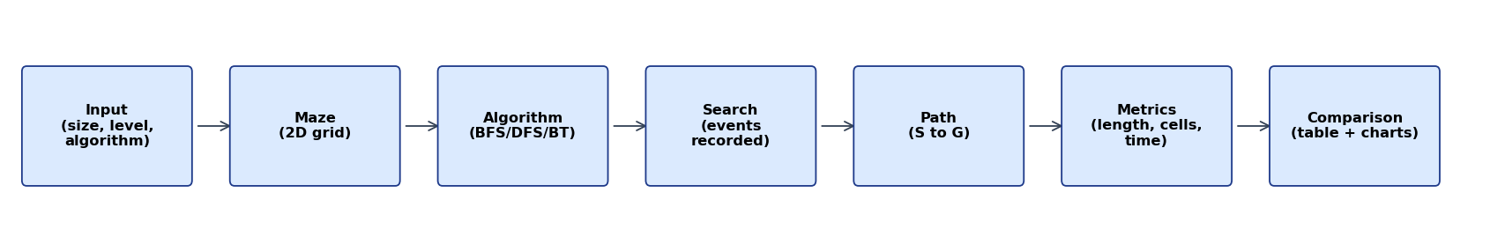
Figure 4.1: Workflow of the application
The user sets the options, generates a maze and presses Solve. The chosen algorithm searches and records events. The interface replays the events as a picture sequence, and the metrics module collects the numbers. Compare All repeats the process for all three algorithms on the same maze.

5. Algorithms and Methodology

5.1 Maze representation
The maze is stored as a 2D grid: a list of rows, where each row is a list of single characters. A cell is addressed as (row, column), and row 0 is the top row.
Symbol | Meaning | Colour in the app
S | Start | Green
G | Goal | Red
. | Open cell (can walk) | Light grey / white
# | Wall (cannot walk) | Dark

A small example maze (5 rows by 5 columns):
S . # . .
. # # . #
. . . # .
. # . . .
. . . # G
From a cell we can move to up to four neighbours (Up, Right, Down, Left) if they are inside the grid and not walls. Every algorithm uses this same order of directions. A fixed order makes the results repeatable and the comparison fair.

Example: neighbours of a cell
For the cell (2, 1) in the example, Up is (1, 1) which is a wall, Right is (2, 2) which is open, Down is (3, 1) which is a wall, and Left is (2, 0) which is open. So the neighbours are (2, 2) and (2, 0), in that order.

5.2 Breadth-First Search (BFS)

Concept
BFS explores the maze in rings. First it looks at every cell one step from the start, then every cell two steps away, then three steps, and so on, like the ripples when a stone is dropped in water. It uses a queue: the cell that has been waiting the longest is explored next.

Steps
- Put the Start cell in the queue and remember it as discovered.
- Take the cell at the FRONT of the queue.
- If it is the Goal, stop and rebuild the path using the parent links.
- Otherwise, for each open neighbour that is not discovered yet: mark it discovered, remember its parent, and add it to the BACK of the queue.
- Repeat from step 2. If the queue becomes empty, there is no path.

Pseudocode
BFS(grid, start, goal):
queue <- [start]; discovered <- {start}; parent[start] <- none
while queue is not empty:
cell <- remove front of queue
if cell == goal: return path rebuilt from parent
for each open neighbour nb of cell:
if nb not in discovered:
add nb to discovered; parent[nb] <- cell
add nb to back of queue
return "no path"

Why BFS finds the shortest path
Because the queue keeps cells in order of their distance from the start, all cells at distance d are explored before any cell at distance d + 1. The first time the Goal is reached, no shorter route can exist, otherwise the Goal would have been found in an earlier ring. This guarantee holds only when every move costs the same, that is, in an unweighted maze.

Advantages and limitations
Advantages | Limitations
Guarantees the shortest path in an unweighted maze | May visit many cells, because it spreads in all directions
Simple and predictable | The queue can grow large (it holds a whole ring of cells)
Always finds a path if one exists | Does not use any hint about where the goal is

Complexity
Let R be the number of rows and C the number of columns, so there are R x C cells. Each cell enters the queue at most once and has at most 4 neighbours, so the time is O(R x C). The queue and parent table need O(R x C) memory in the worst case.

5.3 Depth-First Search (DFS)

Concept
DFS goes as deep as it can along one corridor. Only when it gets stuck does it jump back to the most recent unexplored branch. It uses a stack: the newest cell is explored first. Think of walking down a corridor and always taking the first turn you see, until you hit a wall.

Steps
- Push the Start cell on the stack.
- Pop the cell on TOP of the stack. If already visited, skip it.
- Mark it visited and remember its parent.
- If it is the Goal, stop and rebuild the path.
- Push its unvisited open neighbours on the stack (in reverse so the first direction is tried first).
- Repeat from step 2. If the stack becomes empty, there is no path.

Pseudocode
DFS(grid, start, goal):
stack <- [(start, none)]; visited <- {}
while stack is not empty:
(cell, from) <- pop top of stack
if cell in visited: continue
add cell to visited; parent[cell] <- from
if cell == goal: return path rebuilt from parent
for each open neighbour nb of cell (reverse order):
if nb not in visited: push (nb, cell)
return "no path"

Advantages and limitations
Advantages | Limitations
Very simple; often needs little memory | Does NOT guarantee the shortest path
Can find a path quickly if it happens to go the right way | Can wander far in the wrong direction before returning
Finds a path whenever one exists (visited cells are never repeated) | The result depends on the order of directions

Why DFS may not be shortest
DFS accepts the first path that reaches the Goal. If it chooses a long winding corridor before a short one, it will return the long route. In our tests the DFS path was longer than the BFS path on most mazes with shortcuts (see Section 7).

Complexity
Each cell is visited at most once, so the time is O(R x C). The stack may hold many cells, so memory is O(R x C) in the worst case.

5.4 Recursive Backtracking

Concept
Backtracking solves a problem by building a solution one choice at a time. If a choice leads to a dead end, it undoes that choice and tries the next option. In a maze: stand on a cell, choose a neighbour, walk into it, and if that whole branch fails, step back and try another neighbour. The pattern is:
CHOOSE -> EXPLORE -> DEAD END -> UNDO -> TRY ANOTHER CHOICE
The algorithm keeps a list called the current path. Choosing a cell adds it to the list. Undoing a cell removes it from the list. When the Goal is reached, the current path is the answer.

Steps
- CHOOSE: mark the cell as tried and add it to the current path.
- If the cell is the Goal, return success.
- EXPLORE: for each neighbour that has not been tried, call the same function recursively.
- If any recursive call returns success, return success.
- DEAD END: if no neighbour worked, UNDO: remove the cell from the current path, count one backtracking operation, and return failure to the caller.

Pseudocode
Solve(cell):
mark cell as tried; append cell to path # CHOOSE
if cell == goal: return true
for each open neighbour nb of cell: # EXPLORE
if nb not tried:
if Solve(nb): return true
remove cell from path; backtracks <- backtracks + 1 # UNDO
return false # DEAD END

How is it different from DFS?
This is a favourite judge question, so we answer it honestly. Both go deep first. In our grid maze both mark cells as tried, so they explore cells in the same order and usually visit the same cells. The difference is in the mechanism and what we can observe: DFS uses an explicit stack of waiting cells and records parents, while Backtracking uses recursion and a current path that is visibly built and undone. Backtracking is a general problem-solving pattern (also used for Sudoku and N-Queens), whereas DFS is a graph-traversal algorithm. In this project the Backtracking run also reports how many undo operations happened.

Why we mark tried cells
If cells were un-marked after being undone, the algorithm could re-try the same cells through many different routes in a maze with loops, and the work could grow exponentially. Marking tried cells keeps the work proportional to the number of cells.

Advantages and limitations
Advantages | Limitations
Makes the choose / explore / undo idea very visible | Does not guarantee the shortest path
The same pattern solves many other puzzles | Deep recursion on huge mazes can hit Python's recursion limit (we raise the limit and cap size at 41)
Easy to write recursively | Without marking tried cells, it can become exponentially slow

Complexity considerations
With tried-cell marking, each cell is chosen at most once, so the time is O(R x C) and the recursion depth is at most R x C. Pure backtracking without marking can be exponential in the worst case, which is why general backtracking problems often need pruning (cutting off hopeless branches early). The number of undo operations in a successful run equals the number of visited cells that are not on the final path.

5.5 Comparison of the three algorithms
Aspect | BFS | DFS | Backtracking
Core idea | Level by level | Deep first | Choose, explore, undo
Structure | Queue (FIFO) | Stack (LIFO) | Recursion + path list
Shortest path? | Yes (unweighted) | No guarantee | No guarantee
Finds a path if one exists? | Yes | Yes | Yes
Time (this project) | O(R x C) | O(R x C) | O(R x C)
Memory | Whole ring in queue | Stack of waiting cells | Depth of current path
Shows undo steps? | No | Dead ends only | Yes, counted
Best for | Shortest route | Quick exploration, any route | Puzzles with choices and constraints

There is no universally best algorithm. BFS gives the best path quality, but may explore more cells. DFS or Backtracking may explore fewer cells on some mazes and many more on others, depending on the order of directions and the maze layout.

5.6 Maze generation methodology
- Create a grid full of walls (size made odd).
- Start at cell (1, 1) and repeatedly carve a passage to a random unvisited cell two steps away, using a stack to go back at dead ends. This produces a perfect maze: all open cells are connected and there is exactly one route between any two cells.
- Difficulty: remove a fraction of the walls that separate two corridors (Easy 25%, Medium 8%, Hard 0%). More removed walls create more loops and shortcuts.
- Place S at (1, 1) and G at (size-2, size-2).
- Run BFS to verify that G is reachable; if not, regenerate (up to 50 attempts).
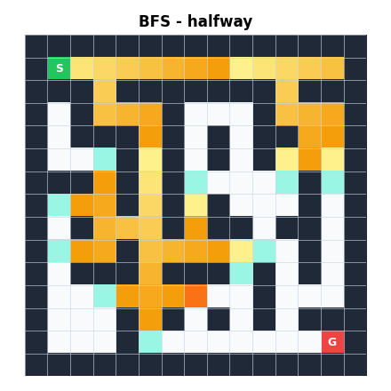  BFS halfway | 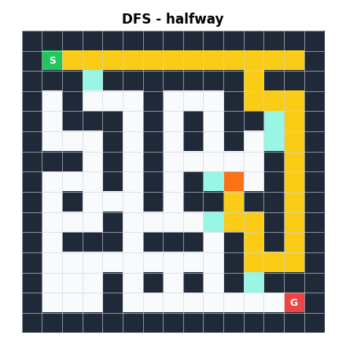  DFS halfway | 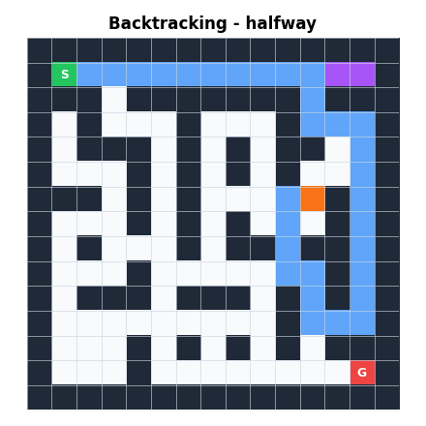  Backtracking halfway
Figure 5.1: The three searches half way through the same 15 x 15 Easy maze (seed 4), drawn by the project code.
In Figure 5.1, BFS (left) has spread as a wide wave of yellow with darker and lighter bands for each level. DFS (middle) has pushed far down a few corridors. Backtracking (right) shows its current path in light blue and cells it has already undone in purple.

6. Technologies and Implementation

6.1 Technologies used
Technology | Why it was chosen
Python | Easy to read, ideal for learning algorithms, rich libraries, and the course language for many DAA labs.
Streamlit | Builds a web interface with plain Python (no HTML/JavaScript needed); runs with one command; has buttons, sliders, tables and tabs built in.
Matplotlib | Draws the maze as an image and the comparison bar charts; widely known and reliable.
NumPy | Holds the colour image of the maze efficiently.
pandas | Builds the comparison table shown in the UI.
Standard library | collections.deque (queue), time.perf_counter (timing), random (maze generation), sys (recursion limit).

No database, login system, machine learning or cloud service is used, because they are not needed and would add complexity.

6.2 Project architecture
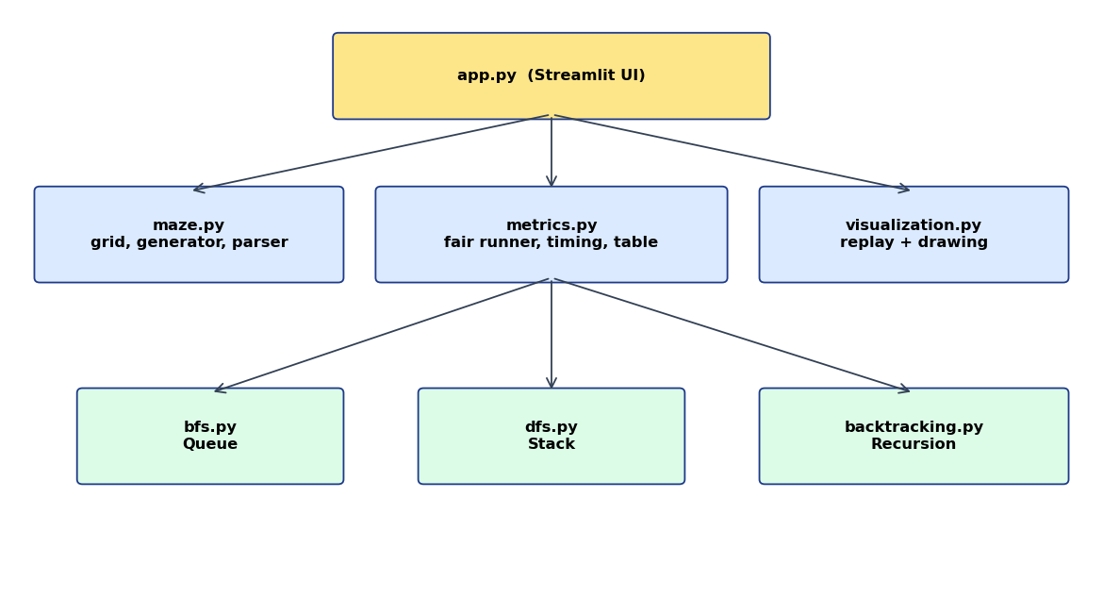
Figure 6.1: Module architecture
The user interface (app.py) never contains algorithm logic. It calls metrics.py to run algorithms, maze.py to create mazes and visualization.py to draw them. This separation makes each file small and easy to explain.

6.3 Module structure
File | Responsibility
app.py | Streamlit interface: sidebar, buttons, replay controls, results, comparison tabs, session state.
maze.py | Grid symbols, neighbour function, maze generator, text parser and validator, path reconstruction and validation, event helper.
bfs.py | Breadth-First Search with event recording.
dfs.py | Depth-First Search with event recording.
backtracking.py | Recursive Backtracking with event recording and undo counting.
metrics.py | Fair runner, repeated timing, comparison table, summary notes.
visualization.py | Replay-state builder, maze drawing, legend, comparison charts.
test_algorithms.py | Nine automated tests.
run_benchmarks.py | Prints real measurements for the report and slides.

6.4 Data structures
Data structure | Where used | Purpose
List of lists | The maze grid | Store the maze rows and columns.
Tuple (row, col) | Cells | A cell is a small, hashable pair.
deque | BFS queue | Fast removal from the front and insertion at the back.
list used as a stack | DFS stack | Push and pop at the end.
set | Visited / discovered cells | Instantly check whether a cell was seen.
dict | parent and level maps, events, results | Reconstruct the path; store event data.
list of dicts | Events | The recorded history that the UI replays.

6.5 The event-recording design
A basic solver returns only the final path. Our solvers also return a list of events in order. Each event is a small dictionary with a type, a cell and a message.
Event type | Used by | Meaning
visit | BFS, DFS | A cell is taken from the queue/stack and explored (becomes the current cell).
explore | All | A cell is added as a candidate (queue/stack) or about to be tried (Backtracking).
choose | Backtracking | A cell is added to the current path.
dead_end | DFS, Backtracking | No new cell can be reached from here.
backtrack | Backtracking | The cell is removed from the current path (undo).
goal | All | The goal cell was reached.
path | All | The final path (stored in the event).
no_path | All | The search ended without reaching the goal.

To draw step k, visualization.build_state applies the first k events to an empty snapshot (visited, waiting, current, path, backtracked, final path). draw_maze then colours the grid. Showing a larger k each time creates the animation. Because the animation is a replay of recorded events, it can be paused, stepped backwards, or scrubbed with a slider, and the same events always give the same picture.

6.6 Algorithm implementation details

Common result format
Every algorithm returns the same dictionary: algorithm name, found (True/False), path, path length, visit order, visited count, backtrack count, peak size (largest queue, stack or recursion depth) and events. A single format lets metrics and the UI treat all algorithms identically.

BFS code core
queue = deque([start]); discovered = {start}; parent = {start: None}
while queue:
cell = queue.popleft()
if cell == goal: ...rebuild path...
for nb in neighbors(grid, cell):
if nb not in discovered:
discovered.add(nb); parent[nb] = cell; queue.append(nb)

DFS code core
stack = [(start, None)]; visited = set()
while stack:
cell, came_from = stack.pop()
if cell in visited: continue
visited.add(cell); parent[cell] = came_from
if cell == goal: ...rebuild path...
for nb in reversed(neighbors(grid, cell)):
if nb not in visited: stack.append((nb, cell))

Backtracking code core
def solve(cell):
visited.add(cell); path.append(cell) # choose
if cell == goal: return True
for nb in neighbors(grid, cell):
if nb not in visited and solve(nb): # explore
return True
path.pop(); backtracks += 1 # undo
return False

6.7 Fair timing
Execution time is measured with time.perf_counter(), Python's high-resolution timer. For each algorithm the app runs the search once with event recording (for the animation) and then N more times without recording (for timing, default 20, adjustable up to 50). Recording events would add extra work that is not part of the algorithm, so it is excluded from timing. The app shows the average, the minimum and the maximum. On small mazes the times are fractions of a millisecond, so small differences can be caused by the computer rather than by the algorithm. For this reason the app reports averages, shows the range, and never uses time alone to name a winner.

6.8 User interface implementation
- Header: title and tagline "Visualize. Explore. Compare."
- Sidebar: maze size, difficulty, seed, algorithm, animation speed, timing trials and a colour legend.
- Buttons: Generate Maze, Solve, Compare All, Reset.
- Visualizer: the maze picture, replay buttons, step slider and a message box that explains each step.
- Results: path length, visited cells, average time and backtracking count, plus a short explanation of the chosen algorithm.
- Tabs: Comparison (table, charts, notes, final pictures), How each algorithm works, and About fairness.
- Session state: Streamlit re-runs the script on every click, so the maze, results and current replay step are kept in st.session_state.

Colour scheme
State | Colour
Start | Green
Goal | Red
Wall | Dark grey / black
Visited | Yellow (BFS: bands of yellow by level)
Waiting in queue / stack | Teal
Current cell | Orange
Current path (Backtracking) | Light blue
Backtracked (undone) | Purple
Final path | Deep blue

6.9 Error handling
- Invalid maze text (wrong characters, uneven rows, missing or duplicate S/G) shows an error message and leaves the current maze unchanged.
- Unsolvable mazes return found = False, an empty path and a "no_path" event; the UI shows a warning.
- Toggling the start or goal cell is refused.
- Maze size is clamped to a safe range and made odd; unknown difficulty values raise a clear error.
- The recursion limit is raised temporarily for Backtracking and restored afterwards.

7. Results, Testing and Performance

7.1 How results were obtained
Automated tests were run with `python test_algorithms.py` and all nine tests passed in the development environment. Counts of path length, visited cells and backtracking operations were produced by `python run_benchmarks.py` using fixed seeds, so you will obtain the same counts on your computer. Execution times depend on the computer, so they are left as placeholders for you to fill from your own run. Screenshots must also be taken from your own running application.
Action for the team: run the application and benchmarks, then replace every yellow placeholder with the real value.

7.2 Test cases
ID | Test | Expected result | Observed
T1 | Solvable 5 x 5 maze, all three algorithms | Each returns a valid path from S to G | Pass (automated)
T2 | Unsolvable maze (wall blocks the way) | found = No, empty path, "no_path" event for all three | Pass (automated)
T3 | Goal right next to the start | Path length = 1 for all | Pass (automated)
T4 | Start walled in | No path for all three | Pass (automated)
T5 | BFS optimality: 45 generated mazes (3 levels x 15 seeds), compared with an independent shortest-distance check | BFS length equals the true shortest; DFS and Backtracking are never shorter | Pass (automated)
T6 | Generated mazes of sizes 7, 15, 25, 41 at all levels | All solvable | Pass (automated)
T7 | Backtracking count | Undo count = visited cells - cells on final path | Pass (automated)
T8 | Replay of all events | Final snapshot shows exactly the final path | Pass (automated)
T9 | Maze not changed by algorithms | Grid identical before and after Compare All | Pass (automated)
T10 | Invalid maze text inputs (6 bad cases) | Each rejected with a ValueError message | Pass (automated)
T11 | Streamlit interface: generate, solve, play, compare, reset, manual maze | All controls work without errors | [INSERT RESULT FROM YOUR MANUAL TEST]

7.3 Test results on mazes of different sizes
The counts below were produced with run_benchmarks.py (difficulty Medium unless stated, seed 1). Times are placeholders.
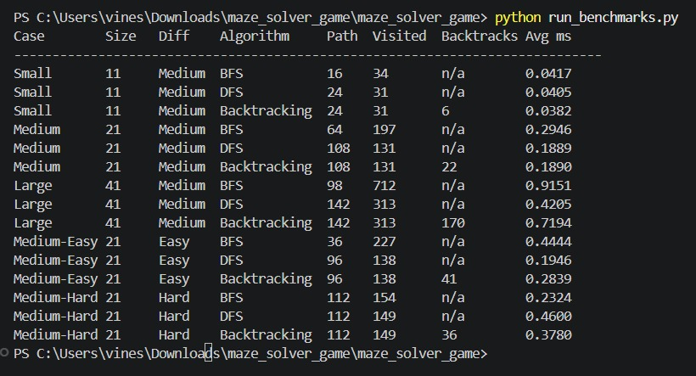

7.5 Sample run on the same maze
Figure 7.1 shows the final state of all three algorithms on one maze (15 x 15, Easy, seed 4), drawn by the project code. For this maze BFS found a path of 24 steps after visiting 111 cells. DFS found a path of 52 steps after visiting 62 cells. Backtracking found the same 52-step path after visiting 62 cells with 9 undo operations.
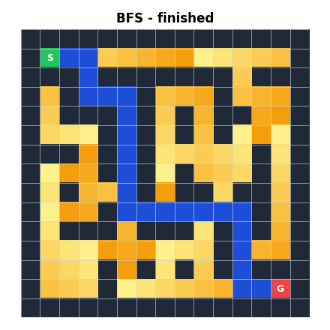  BFS final | 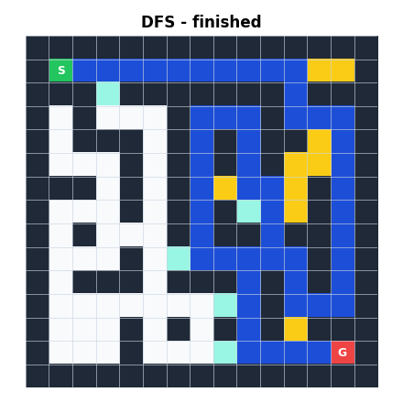  DFS final | 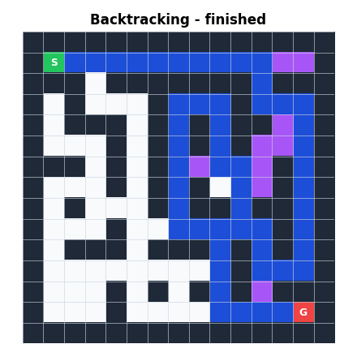  Backtracking final
Figure 7.1: Final state of each algorithm on the same maze

7.7 Performance on your computer

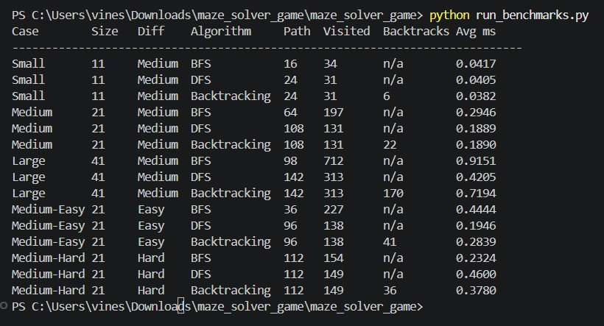

7.8 Analysis
The analysis below uses only the counts that were measured (Section 7.3 and 7.4). Add statements about time after you fill in your own timings.
- Path quality: BFS returned the shortest path in every test, as theory predicts. On the Medium 21x21 maze BFS found 64 steps while DFS and Backtracking found 108 steps. On the Hard maze, which has only one route, all three found the same 112-step path.
- Cells explored: On the Medium, Large and Easy mazes BFS visited more cells than DFS (for example 712 versus 313 on the 41x41 maze). On the Hard maze the numbers were close (154 versus 149). So the number of visited cells depends on the maze layout and difficulty; it is not fixed by the algorithm alone.
- DFS versus Backtracking: They produced identical paths and visited counts in every test. This is expected because both use the same direction order and mark cells as tried. The extra information from Backtracking is the undo count, which equals visited cells minus path cells (for example 313 - 143 = 170 on the large maze).
- Effect of difficulty: With more shortcuts (Easy), the gap between the BFS path and the DFS path was largest (36 versus 96 steps). With no shortcuts (Hard), the gap disappeared because only one route exists.
- Timing: Times for 11x11 to 41x41 mazes are tiny (fractions of a millisecond to about a millisecond), so differences can be caused by computer noise. [INSERT YOUR OWN TIMING OBSERVATIONS HERE]
- No universal winner: BFS is best when path length matters. DFS and Backtracking may explore fewer cells on some mazes, but may return a longer path. A different maze or direction order can change which explores fewer cells.

7.9 Limitations of the evaluation
- Each result comes from a small number of mazes; it is not a statistical study.
- Timing is affected by the computer, other programs and Python itself.
- Only one direction order (Up, Right, Down, Left) was tested.
- Event recording is excluded from timing, so animation speed does not reflect algorithm speed.

8. Conclusion, Future Scope and References

8.1 Conclusion
The Maze Solver Game achieves its main goal: it lets users watch BFS, DFS and Backtracking solve the same maze and compare them using measurable results. All three algorithms were implemented correctly and verified by automated tests, including an independent check that BFS finds the shortest path. The event-replay design makes each algorithm's decisions visible: BFS spreads in rings, DFS dives deep, and Backtracking shows choosing and undoing. The comparison feature runs every algorithm on the same maze with the same start and goal, resets the algorithm state between runs, and presents timing carefully as an average. The project avoids misleading statements: it does not claim that DFS is always faster or that BFS is always best.

8.2 Lessons learned
- Recording events during the search (instead of only the final answer) makes visualization simple, repeatable and easy to pause or scrub.
- A fair comparison needs identical inputs, fresh state and careful timing.
- DFS and Backtracking look similar on a grid; the real difference lies in the mechanism and the general-purpose nature of Backtracking.
- Separating the project into small modules made testing and explanation much easier.
- Marking tried cells is essential to keep Backtracking from re-doing work.
- Testing with an independent shortest-distance check gives more confidence than comparing an algorithm with itself.

8.3 Future improvements
- Click-to-draw maze editor and drag-to-move Start and Goal
- Other maze generators (Prim, Kruskal) and loading mazes from images or files
- Benchmark mode: run many random mazes and report averages and spread
- Export of results to CSV and the charts as images
- Highlighting the active line of pseudocode while the animation plays
- Side-by-side live animation of all three algorithms
- Quiz mode for classroom use

8.4 Scalability
The current limit of 41 x 41 keeps the animation smooth and the recursion safe. To scale to larger mazes, Backtracking can be rewritten with an explicit stack to avoid recursion limits, the replay can sample events more sparsely, and rendering can use faster plotting. Because the algorithms are O(R x C), the search itself handles much larger grids than the animation can display.

8.5 Additional algorithms as future work
Algorithm | Idea | Why it would be interesting
Dijkstra | Always expand the cheapest-cost cell using a priority queue | Handles weighted mazes (mud, water, one-way costs); equals BFS when all costs are 1
A* (A-star) | Dijkstra plus a guess of the remaining distance (heuristic) | Usually explores far fewer cells while still finding a shortest path with a good heuristic
Bidirectional BFS | Search from both Start and Goal | Reduces explored cells
Iterative deepening DFS | DFS with increasing depth limits | Combines low memory of DFS with shortest paths of BFS

8.6 References
- T. H. Cormen, C. E. Leiserson, R. L. Rivest and C. Stein, Introduction to Algorithms, MIT Press (chapter on graph algorithms: BFS and DFS).
- S. Dasgupta, C. Papadimitriou and U. Vazirani, Algorithms, McGraw-Hill (graph search and backtracking).
- R. Sedgewick and K. Wayne, Algorithms, Addison-Wesley (graph processing).
- Python documentation: collections.deque, time.perf_counter, random. https://docs.python.org/3/
- Streamlit documentation. https://docs.streamlit.io/
- Matplotlib documentation. https://matplotlib.org/stable/
- Your DAA course notes and lab manual. [ADD YOUR COURSE REFERENCE]
Note: please check the editions and add any additional sources you actually used.

